**Harba Solutions Contractor**

**Timesheet User Guide**

Contents

**Adding Expenses – Including Milage** 1

**Adding Holiday and Sick Pay** 1

**Adding Time** 1

**Submit Timesheets** 1

**Download Timesheets** 4

**View Past Timesheets** 4

**Deadlines** 4

# **Adding Expenses – Including Milage**

Please add in the total value of your expenses e.g Milage in the expense line e.g $200.

In the notes section enter the total value and explanation of what these are expenses are for and who these have been approved by e.g your line manager.

# **Adding Holiday and Sick Pay**

Please add the hours of your holiday or sick days in to your timesheet as standard hours.

In the notes section add an explanation of what days and timesheets you have entered as holiday sick, if these have already been approved please state who these have been approved by e.g your line manager.

# **Adding Time**

The entry fields in the timesheet allow you to enter your hours worked. You should enter your time worked for each task in these fields. You can enter the time in the format **Hours Minutes HH:MM**. For example, to enter 8 hours and 30 minutes you could type in 08:30.

To test if you are using HH:MM or decimal, type in 01:61. In decimal, this will be converted to 01.61 and turn green, whereas in HH:MM this is not valid, so it will revert to the whole hour when you move to the next field.

Remember to double check your hours.

# **Submit Timesheets**

1. **General information**

All sections in Timesheet Portal contain a left hand menu, allowing you navigate to different sections of the timesheet portal. If your screen is not wide enough to see the timesheet, you may want to hide the toolbar using the menu icon (Insert Icon) on the top right of the left hand menu.

Your timesheet for the current week will be shown in the main area. You do not need to create a new timesheet for each week. All you need to do is move to the week you are interested in, Graphical user interface, text, application
if you are assigned to a job for that week then you will see blank or previously created timesheets for that week. To move between different weeks, use the date navigation arrows.

To move between different weeks quickly, you can also use the calendar in the toolbar which is available by clicking on the date navigation panel in the top right of your timesheet page.

1. **Save & submit**

You may save your timesheet before the submission date, so that you can enter your hours worked as you go. After saving your timesheet, your hours entered will be reloaded when you next log in. To save your timesheet, click on the *Save* *Draft* icon, located next to the submit button on the bottom right of the timesheet form.

    
To submit your timesheet, click the submit button on the bottom of the timesheet form. If you have been assigned multiple approvers, you can select the one for which you want to approve your timesheet using the drop-down list at the bottom of the timesheet.  Once you submit your timesheet, you will not be able to make any changes to it. An email will automatically be sent to your approver when you submit your timesheet, and you will receive an email when the timesheet is approved or rejected.

**Rejected timesheets**

If your timesheet is rejected by your approver, you will receive an email from Timesheet Portal. Your timesheet will also have the *Rejected*status icon and a message on top of the page to state why it was rejected.



To resubmit a rejected timesheet, make your amends as if you were submitting it the first time, and click on the Submit button. If you do not agree with this note, please call your approver before resubmitting.

**Add a daily note**

To add notes relating to a specific day, click on time entry field for the day. If your screen is large enough, a small box will appear on the right hand side of the window, allowing you to enter your notes. If you are using a smaller display, the notes box may appear next to the time entry field. You can enter your note by simply typing any non-numeric character whilst on the time entry field, or by clicking in the notes box and entering your note there.

Once you have entered a note for a specific time entry, you will see a small yellow square in the top-right corner of the time entry field. You can edit your note by clicking back on the time entry field and editing it in the notes box. Alternatively, you can click on *Show Notes*at the bottom of the timesheet. This will show all your notes created within the timesheet itself.

To delete a note, click on the time entry field which contains the note, or click on the note text in the notes table if you have previously clicked on *Show Notes*. To delete the note, clear the text in the notes box and click out of the box to save.

# **Download Timesheets**

Once your timesheet has been submitted, you may download it for printing. You will need Adobe Acrobat reader installed to view the downloaded timesheet, which is produced in the PDF format. To download a timesheet, open up the timesheet by navigating to the timesheet week, or click on *View*from the timesheet overview (see next section). You will see a *Download Timesheet*icon at the bottom of the timesheet, as illustrated in the screenshot below

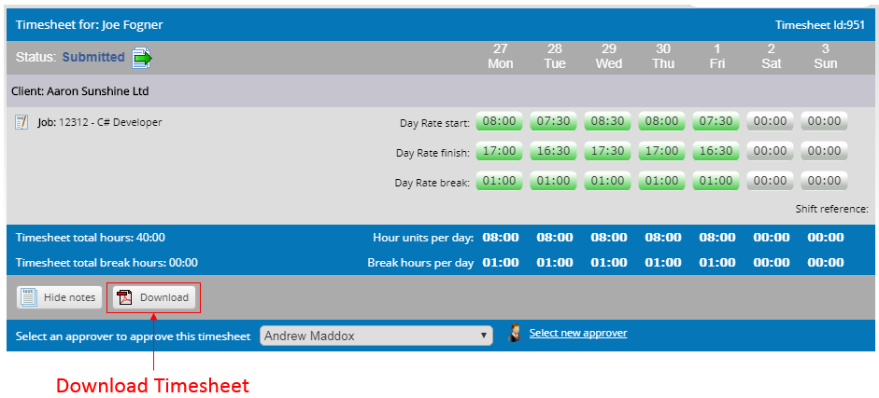

# **View Past Timesheets**

To view your past timesheets, click on *Overview*in the left hand navigation. This will present a table listing all your current and previous timesheets, showing basic information about the timesheet, such as its current status (submitted/approved/rejected). You can adjust the dates and apply filters on the status. If you see a status of *Exported*, this usually means it has been exported into your agency’s payroll / billing system. This can only happen if a timesheet is already approved.

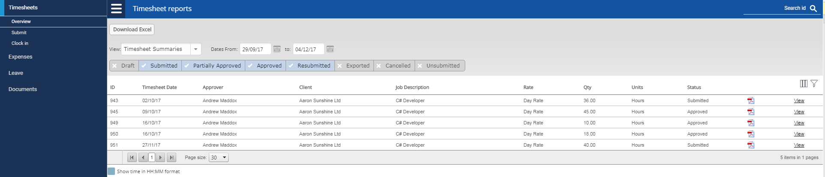

To view the full details of a timesheet, click *View*on the right hand side to open it, or click on the PDF icon to download it as a PDF. You can also download the list of timesheets as an Excel file by clicking on *Download Excel*at the top of the page.

# **Deadlines**

* Timesheet Submission for week worked – End of Day Sunday for the previous week worked e.g you worked Sunday – Saturday, 7th December - Your timesheet is due for submission Sunday, 8th December.
  + If timesheets are not submitted in time, pay may be rolled over to the next payroll week due to payroll submission deadlines.